SOC LOG ANALYSIS & DETECTION

Project Title
Web Server Security Assessment – SOC Log Analysis & Detection

Environment
- Target System: Ubuntu Server (LAMP Stack)
- Attacker System: Kali Linux
- Environment Type: Controlled Lab
- Services Analyzed: SSH, FTP, MySQL, SMTP

Objective
The objective of this report is to analyze system and application logs generated during simulated attacks, identify Indicators of Compromise (IOCs), detect malicious behavior, and recommend mitigation actions from a SOC analyst perspective.

Overview of SOC Log Analysis
Log analysis is a critical responsibility of a Security Operations Center (SOC). It involves monitoring authentication events, service access logs, and application activity to identify unauthorized access, brute-force attempts, and misuse of services.
In this project, simulated penetration testing activities were performed to understand how real-world attacks appear in logs and how SOC analysts detect and respond to them.

Scope of Log Analysis
The following logs were analyzed:
- SSH Authentication Logs (/var/log/auth.log)
- FTP Service Logs (/var/log/vsftpd.log)
- MySQL Database Logs (/var/log/mysql/mysql.log)
- SMTP Mail Logs (/var/log/mail.log)

SSH Log Analysis and Detection

Log File
/var/log/auth.log
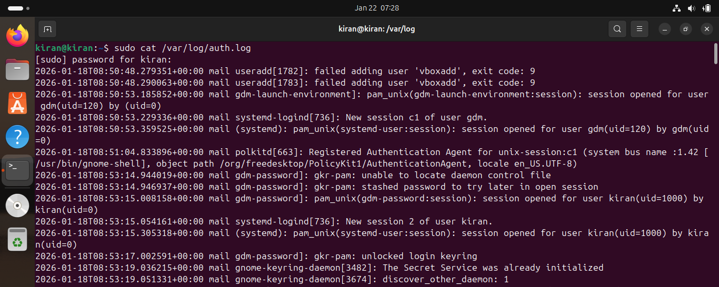
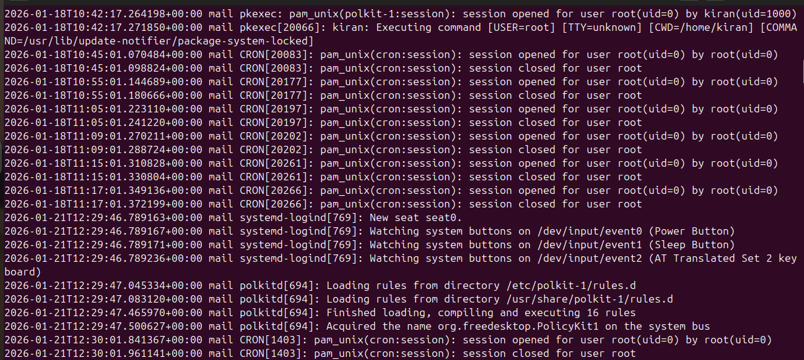

Observed Activity
- Multiple failed SSH login attempts from a single source IP
- Repeated authentication failures within a short time interval
- Successful login after multiple failed attempts

Sample Log Indicators
- Failed password for invalid user
- Failed password for root
- Accepted password for user

Indicators of Compromise (IOCs)
- High number of failed login attempts from one IP
- Login attempts for non-existent users
- Brute-force behavior patterns
Detection Rule:
Condition: More than 5 failed SSH login attempts from the same IP within 1 minute
Action: Generate Brute Force Alert

SOC Analysis
This activity indicates an SSH brute-force attack where an attacker attempts multiple username and password combinations to gain unauthorized access.

Severity
High

FTP Log Analysis and Detection

Log File
sudo nano /etc/vsftpd.conf
log_ftp_protocol=YES
sudo systemctl restart vsftpd
/var/log/vsftpd.log
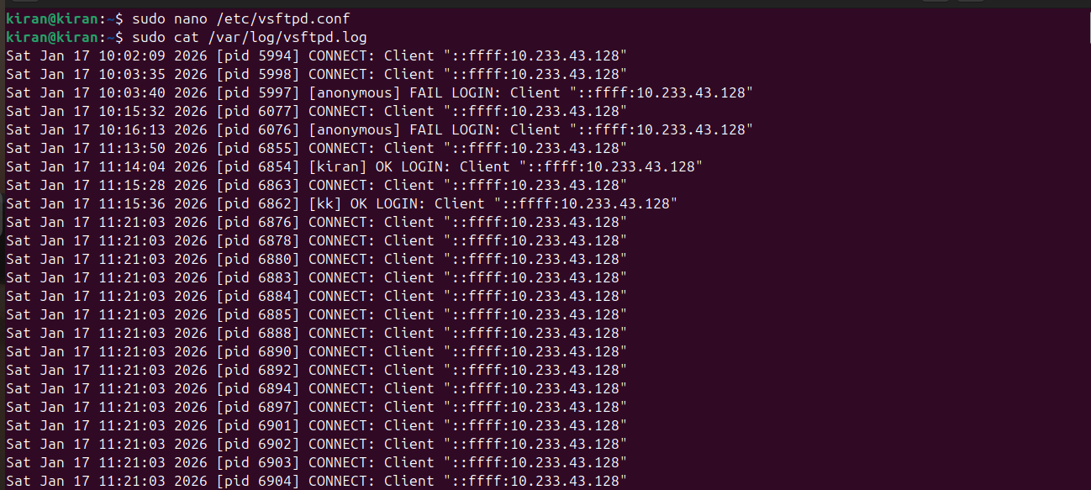
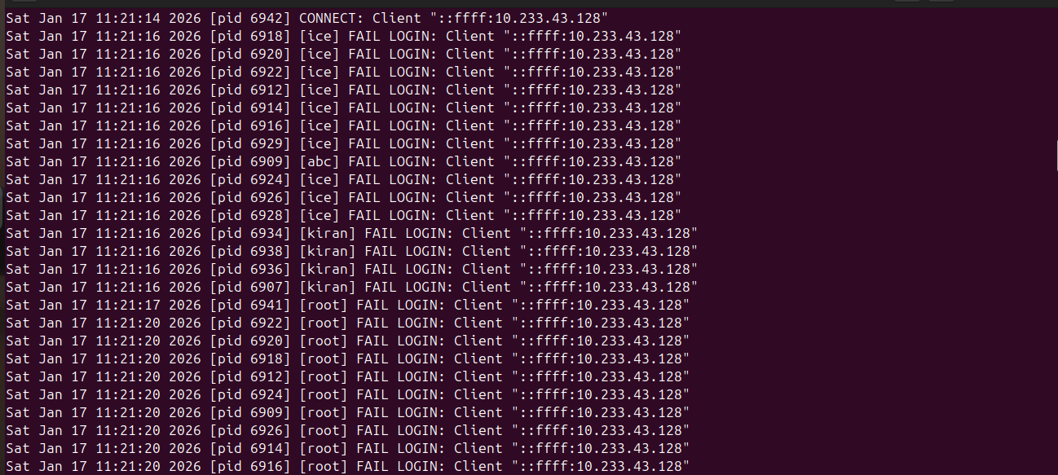

Observed Activity
- Anonymous FTP login attempts
- Failed authentication attempts for valid users
- Successful login using weak credentials

Sample Log Indicators
- Anonymous FTP login allowed
- 530 Login incorrect
- 230 Login successful

Indicators of Compromise (IOCs)
- Anonymous access enabled
- Repeated login failures
- Unauthorized file access attempts

Detection Logic
If anonymous FTP login detected → Policy Violation Alert
If repeated FTP login failures from same IP → Brute Force Alert

SOC Analysis
FTP services are commonly abused for unauthorized access and data exfiltration. Anonymous login increases attack surface and risk.

Severity
Medium to High

MySQL Log Analysis and Detection

Log File
- sudo nano /etc/mysql/mysql.conf.d/mysqld.cnf
- general_log = ON
- general_log_file = /var/log/mysql/mysql.log
- sudo systemctl restart mysql
- /var/log/mysql/error.log
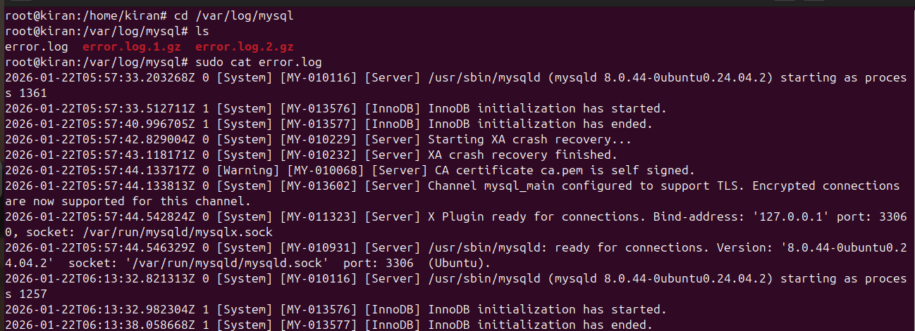


Observed Activity
- Remote login attempts using privileged accounts
- Multiple failed authentication attempts
- Database enumeration activity

Sample Log Indicators
- Access denied for user
- Authentication failed
- Query execution from remote IP

Indicators of Compromise (IOCs)
- External IP attempting database access
- Repeated authentication failures
- Use of high-privileged accounts

Detection Logic
If MySQL login attempt from external IP → Unauthorized Access Alert
If multiple failed database logins → Credential Abuse Alert

SOC Analysis
Database services should not be exposed publicly. These logs indicate credential abuse and potential data compromise attempts.

Severity
High

SMTP Log Analysis and Detection

Log File
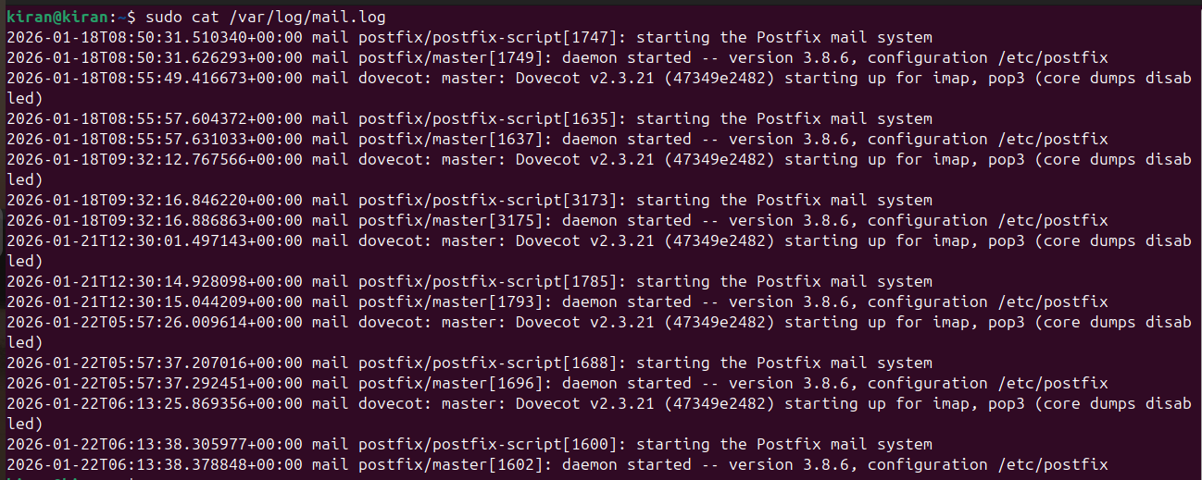
/var/log/mail.log

Observed Activity
- Unauthorized SMTP connections
- Open relay testing behavior
- Suspicious email sending attempts

Sample Log Indicators
- Relay access denied
- Connection from unknown host
- Authentication failure

Indicators of Compromise (IOCs)
- Unknown IP sending mail
- Relay misuse attempts
- Excessive SMTP connections

Detection Logic
If SMTP relay attempt without authentication → Mail Abuse Alert
If multiple mail attempts from unknown IP → Spam Activity Alert

SOC Analysis
SMTP servers are frequently abused for spam and phishing. Improper configuration can lead to blacklisting and reputation damage.

Severity
Medium

Summary of Detected Threats
Service | Attack Type | Detection Source | Severity
SSH | Brute Force | auth.log | High
FTP | Unauthorized Access | vsftpd.log | Medium
MySQL | Credential Abuse | mysql.log | High
SMTP | Mail Relay Abuse | mail.log | Medium

Incident Timeline (Example)
- Reconnaissance detected via service scans
- Brute-force attempts observed in authentication logs
- Successful unauthorized access identified
- SOC alert triggered based on detection rules
- Mitigation actions applied

Mitigation and Response Actions
- Enabled Fail2Ban for SSH brute-force protection
- Disabled anonymous FTP access
- Restricted MySQL access to localhost
- Secured SMTP relay configuration
- Recommended centralized logging and SIEM integration

Lessons Learned (SOC Perspective)
- Log visibility is critical for early attack detection
- Brute-force attacks are easily identifiable through log correlation
- Proper service hardening significantly reduces risk
- SOC analysts must understand both attack methods and defensive controls

Conclusion
This SOC log analysis demonstrates how simulated attacks against web server services can be detected using system and application logs. The project reflects real-world SOC analyst responsibilities including monitoring, detection, analysis, and response, making it relevant for blue-team and cybersecurity analyst roles.

